2015 Thomas W Briggs Community Service Award

David Montague and Memphis Teacher Residency
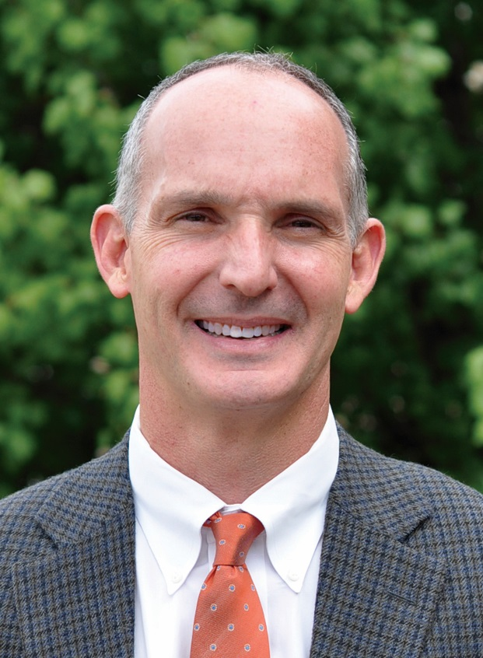
David Montague serves as the Founder and President of Memphis Teacher Residency. Prior to MTR, David served for two years (2005-2007) with Campus Crusade for Christ in East Asia. From 2000-2005, David was the Director of Service Over Self, an urban home-repair ministry in the Binghampton neighborhood of Memphis. From 1987-2000, David was with Morgan Keegan & Co as an investment broker and managing director. David, a lifetime Memphian, graduated in 1986 from Southern Methodist University (Dallas, TX) with a degree in Finance. David has been married to his wife Kelli for 23 years and they have five daughters.

Memphis Teacher Residency

Memphis Teacher Residency is a faith-based teacher preparation program committed to loving others through equal education. MTR believes that in order for transformation to occur it must come from within communities, therefore MTR identifies and partners with specific neighborhoods to promote a community-wide and child based strategy for change. MTR’s focus within these communities is to train, equip, and support excellent educators for the classroom so that every child, regardless of the zip code in which they live, can have access to quality education during elementary and secondary school.

According to the Tennessee Higher Education Commission, there are 43 teacher preparation programs in the state. MTR is one of five that has consistently out-performed all the others. MTR is unique in that its national recruits chose to come to Memphis.

During the residency year, residents train with a mentor, receive coaching, and take Masters in Urban Education coursework through Union University. In addition they receive housing and a $12,000 stipend. After the residency year, residents earn a Master’s in Urban Education degree and agree to teach in Memphis high-needs schools. Currently there are 236 MTR teachers in 31 partner schools in six strategic communities - Alcy Ball/Hamilton, Binghampton, Frayser, Graham Heights, Orange Mound, and Mitchell Heights

